ECA5604- 5g/6g communication
Slot A
M.Pregna
192412350
1. Design a system architecture for Multi-access Edge Computing to reduce latency in
smart traffic applications.
AIM:
To design and simulate a Multi-access Edge Computing (MEC) system architecture for smart traffic applications to reduce communication latency by processing traffic data closer to vehicles.
Matlab Code:
clc;
clear;
close all;

% Number of vehicles
N = 100;

% Generate random traffic data
vehicle_data = randi([10 100], 1, N);

% Processing delay in milliseconds
cloud_delay = 80 + rand(1,N)*40;
edge_delay = 10 + rand(1,N)*10;

% Calculate average latency
avg_cloud_latency = mean(cloud_delay);
avg_edge_latency = mean(edge_delay);

% Latency reduction
reduction = ((avg_cloud_latency - avg_edge_latency) ...
/ avg_cloud_latency) * 100;

% Display results
fprintf('Average Cloud Latency = %.2f ms\n', avg_cloud_latency);
fprintf('Average MEC Latency = %.2f ms\n', avg_edge_latency);
fprintf('Latency Reduction = %.2f %%\n', reduction);

% Plot comparison
figure;
bar([avg_cloud_latency avg_edge_latency]);

set(gca,'XTickLabel',{'Cloud','MEC Edge'});
ylabel('Average Latency (ms)');
title('Cloud vs MEC Latency in Smart Traffic');
grid on;
output:
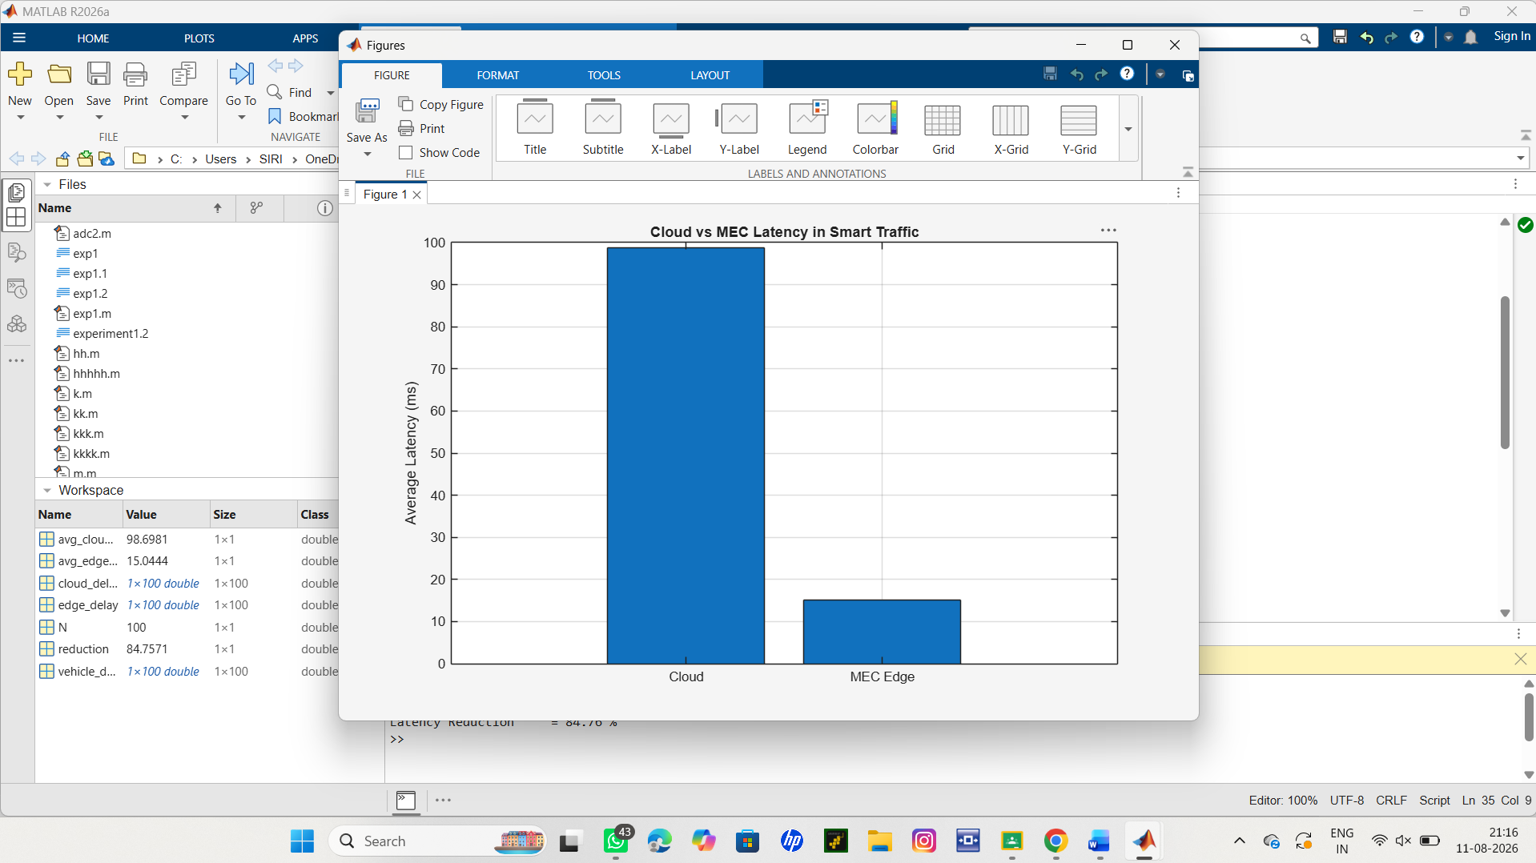
Result:
The MATLAB simulation compares cloud-based processing with MEC-based processing. The MEC server provides significantly lower average latency because traffic data is processed near the vehicles.

2. Develop a cloud-edge communication model for wireless healthcare monitoring.
AIM:
To develop and simulate a cloud-edge communication model for wireless healthcare monitoring in which patient data is processed at the edge before being transmitted to the cloud, thereby reducing communication delay.
Code:
clc;
clear;
close all;

% Number of healthcare data samples
N = 50;

% Generate random patient heart-rate data
HR = randi([60 120],1,N);

% Cloud and Edge delays (ms)
Cloud = 100 + rand(1,N)*20;
Edge = 20 + rand(1,N)*10;

% Average latency
C = mean(Cloud);
E = mean(Edge);

fprintf('Cloud Latency = %.2f ms\n',C);
fprintf('Edge Latency = %.2f ms\n',E);

% Plot comparison
bar([C E]);
set(gca,'XTickLabel',{'Cloud','Edge'});
ylabel('Latency (ms)');
title('Cloud vs Edge Latency');
grid on;
output:
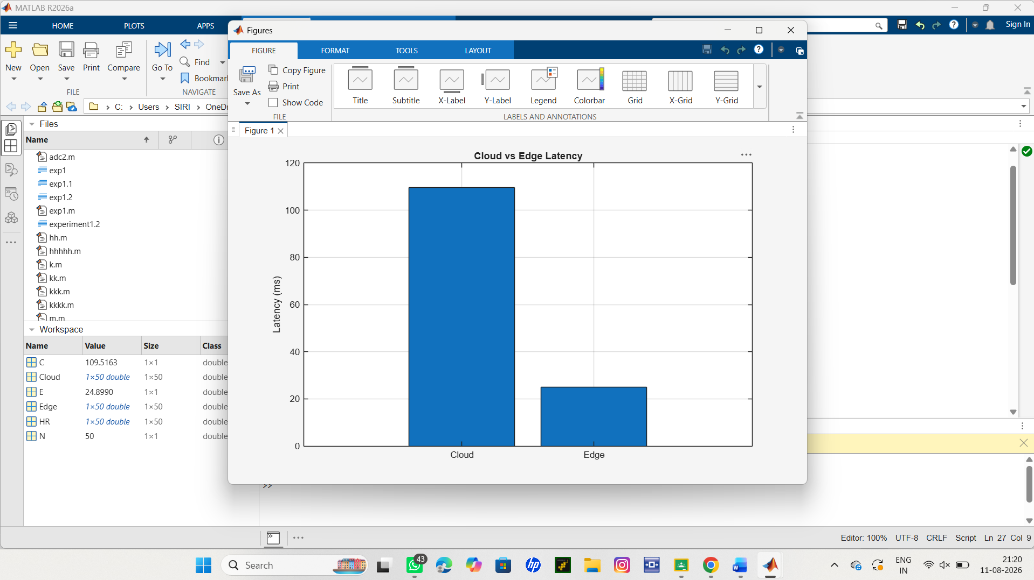

Result:
The simulation shows that edge processing has lower latency than cloud processing, making it suitable for real-time wireless healthcare monitoring and faster emergency alerts.

